HR ANALYTICS WITH TABLEAU REPORT

TEAM ID

NM2023TMID16079

MEMBERS

C.NANDHINI

R.PARAMESHWARI

S.DHIVYA

E.GAYATHRI

PROJECT TITTLE

HR ANALYTICS WITH TABLEAU

PAPER TITTLE

DATA LITERACY WITHTABLEAU

DEATIALS

3 YEAR,

B,SC,MATHEMATICS,

PG&RESEARCH DEPARTMENT OF MATHEMATICS,

KALAIGNAR KARUNANIDHI GOVERENMENT ARTS COLLEGE,

THIRUVANNAMALAI.

UNIVERSITY AFFLIATED

THIRUVALLUVER UNIVERSITY , VELLORE

INTROUDUCTION

* 1. Overview

A brief description about our project

Tableau is the fastly growing and powerfull data visualization tool.Tableau is a business intelligence tool which helps us to analyze the raw data in the form of the visual manner;it may be a graph,report,etc.

Example:If you have any data like big data,Hadoop.SQL,or any cloud data and if you want to analyze that given data in the form of pictorial representation of data, you can use Tableau.

Data analysis is very fast with Tableau, and the visualizations created are in the form of worksheets and dashboards. Any professional can understand the data created using Tableau.

Tableau software doesn't require any technical or any programming skills to operate. Tableau is easy and fast for creating visual dashboards.

There are two types of values in the tableau:

* Demensions: Values that are discrete which can not change with respect to time in nature called Dimension in Tableau.

Example:city name,product name,country name.

* Measures : Values that are continuous which can change eith respect to time in nature called measure in tableau .

Example: profit,sales,discount,population.

Tableau server is a busniness intelligence application that offers browser based analytics anyone can utillze. It is a repaid fire alternative to the slow pace of traditional BI software. It is an online solution meant for sharing,distributing,and collaborating on content created Tableau.

Tableau Public is a free software to facilitate anyone to connect to a spreadsheet or file and create interactive data visualations for the web.It is delivered as a service that permits the user to be up a nd running overnight.With Tableau public users can construct amazing interactive visuals and publish them quickly,without the help of programmers or IT.

It is designed for organisations to facilitate their websites with interactive data visualiations . There are higher limites on the size of data you can keep your underlying data hidden.

Feedback and Iteration gather feedback from users and stakeholders to improve the Tableau dashboards and refine the analysis as needed

Different visualiations

* + - KPL
    - Department wise Attrition
    - No of employees by Age Group
    - Job Satisfaction Rating
    - Education Field wise Attrition
  1. Purpose

HR Analytics are specialized forms of data analytics that use employee-related data and analytical processes to improve HR performance levels and employee retention. Management can use the collected data to make informed decisions about attrition rates and employee retention.

 The use of analytics is revolutionizing HR just as it has revolutionized marketing. HR analytics aims to provide insights into how to manage employees and reach business objectives. The availability of so much data makes it imperative for HR teams to determine which data is most relevant and how to utilize it best. It can be achieved with **HR data analysis**.

Many **business objectives can be leveraged using analytics**. For example, business analytics is used to determine pricing in a department store based on past and present information. In this way, **business analytics is used in today’s business scenario.**

With HR Analytics, you can monitor and improve employee engagement, retention, wellness, productivity, experience, and work culture. This analytics also helps in **hr training and development.**

 Using proper [HR analytics software](https://www.forbes.com/advisor/business/software/best-hr-analytics-software/) allows business managers to rely on actual data to make people-based decisions instead of relying on gut feelings. It can provide analysis of how well an employee is performing as well as insight into where job candidates are falling off of the hiring process. HR analytics measures a broad range of different types of data, but all of it is centered on the people function.

here are a number of HR analytics that a business can measure, but the right ones for you will depend on what you’re wanting to learn and accomplish. The key HR analytics are ones that are typically measured by most organized businesses looking to keep track of their people data. Here is an overview of those key metrics that make a good starting point for most businesses to launch an HR analytics program.

1. Problem Defination & Design Thinking

2.1 Empathy Map

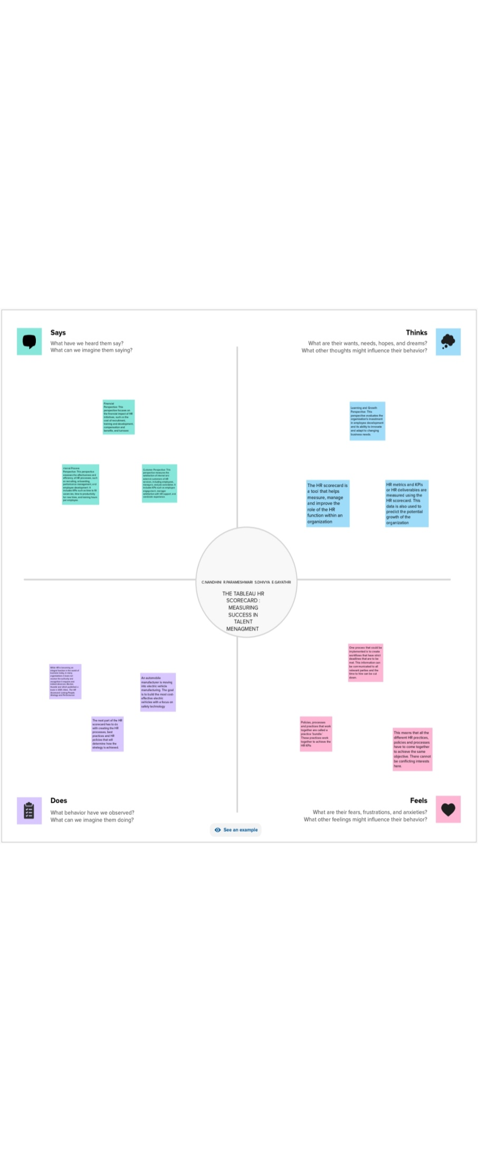

2.2 Ideation and Brainstorming map

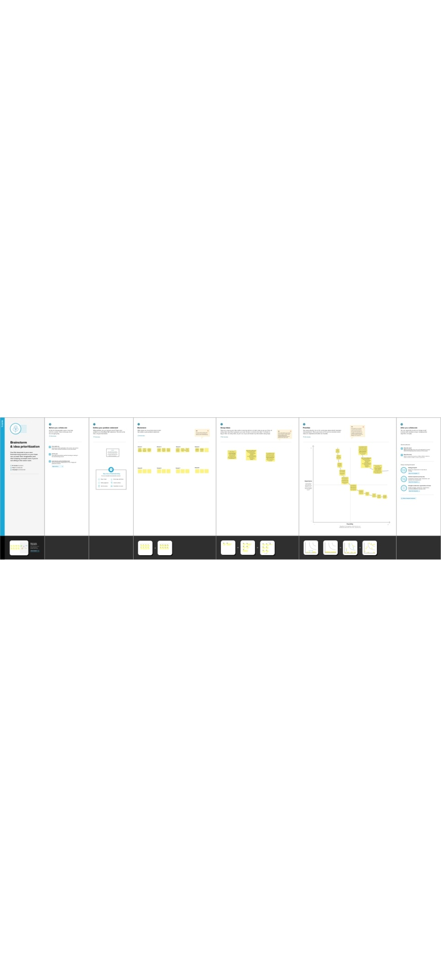

1. RESULT

HR analytics is the process of collecting and analyzing human Resource data in order to improve an organisation workforce performance. The process can also be referred to as talent analytics, people analytics,or even workforce analytics. This method of data analysis takes data that is routinely collected by HR and correlates it to HR and organizational objectives.

Doing so provides measured evidence of how HR initiatives are contributing to the organization goals and strategies.

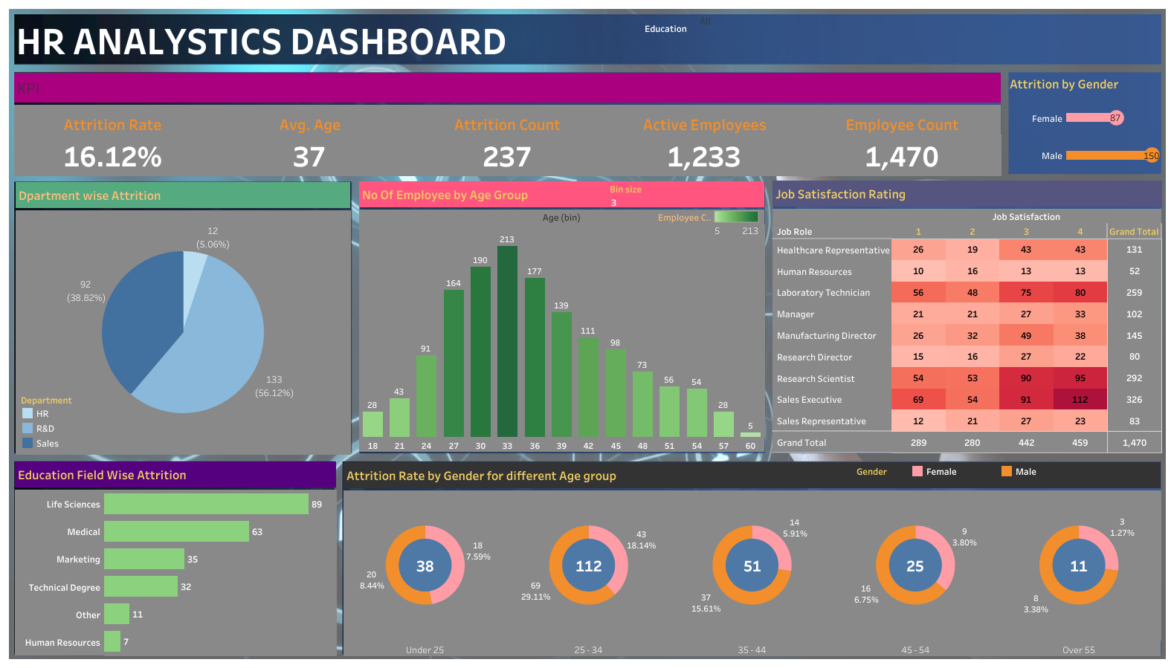

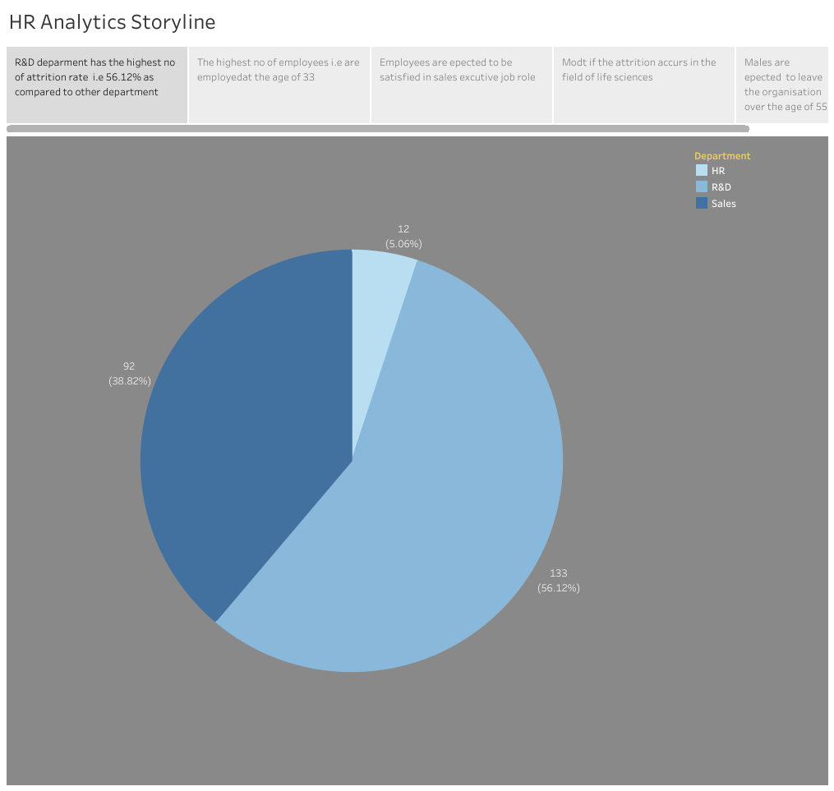

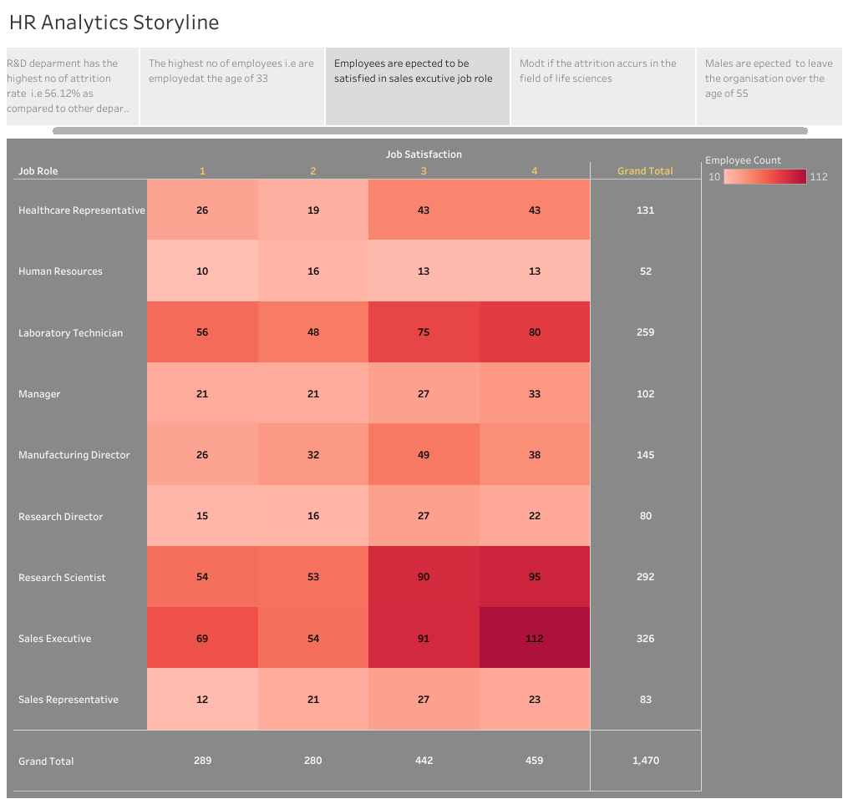

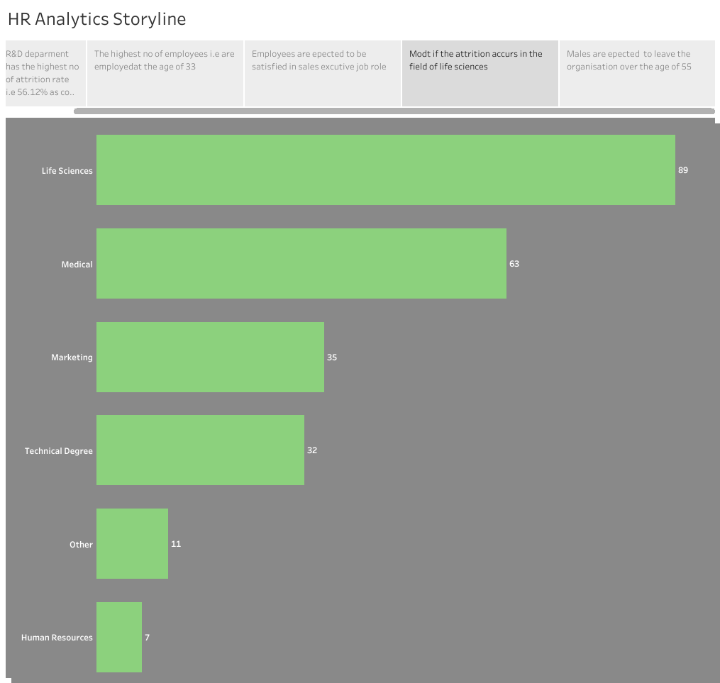

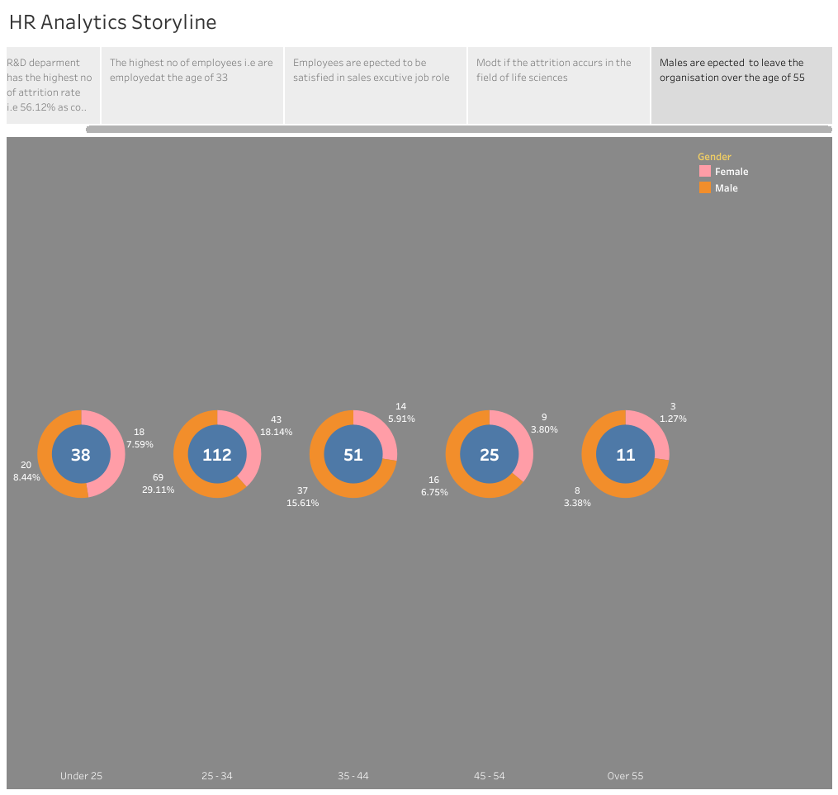

ADVANTAGES & DISADVANTAGES

Advantages

### 1. High Performance:

### Users rate Tableau’s overall performance as strong and secure. It can handle millions of rows of data with ease. The huge advantage of having Tableau is different types of visualization can be created at one shot.

### ****2. Mobile-friendly:****

### There is an accomplished mobile app available for IOS and Android which adds mobility to Tableau users and allows them to keep statistics at their fingertips. The app supports practically that a desktop and online version has.

3. Easy to Upgrade:

Tableau customers are happy with using the latest release of the software because the upgrades are easy to be carried out.

### ****4. Low Cost:****

### Tableau is relatively a low-cost solution compared to other big data counterparts such as Qlik and Business Obje

### ****5. Quality Customer Service:****

Tableau has user and developer community where the queries are answered quickly.

### ****6. Ease of Use:****

It is easy to use since it is simple user interface software. Also, it is simple to drag and drop interface which is very easy to learn.

Disadvantages

### ****1. Poor Versioning****

The main disadvantage of using Tableau is, only recent versions supports revision history and for the older one's package rolling back is not possible.

### ****2. Need Manual Effort:****

Tableau’s parameters are inactive and only a single value can be selected using a parameter. You need to update it manually whenever the data gets change.

### ****3. No Automatic Refreshing of Reports:****

You don’t get an automatic option to refresh your reports with the help of scheduling. Therefore, some manual effort required to update the data in back-end.

### ****4. No Version Control:****

### Once the dashboards and reports are published on the server you can’t get back to the previous levels of data in Tableau. It is not possible to go back and recover old data.

### ****5. Not a Comprehensive Solution****

Even if the Tableau Software is easy to use for BI application, still it doesn’t provide any platform for developing analytic applications that can be widely shared. Also, it doesn’t suit the business that has expanded deployments of broad business.

APPLICATIONS

The area this solution can be apply are recruitment, talent acquisition,employee retention,employee engagementworkforce planning,performance management,cost optimization,employee satisfaction,employee feedback etc,

CONCLUSION

Tableau's powerful data visualization capabilities empower HR professionals to address attrition head-on. By digging deep into data and asking the right questions, HR teams can uncover insights that drive strategic decisions. Through these insights, organizations can implement targeted interventions to improve employee retention, foster a healthier work environment, and create a more engaged and satisfied workforce.

Some findings

* From this deparment wise attrition chart it is clear that Research and Development i.e, R & D has higher rate of about 56.12%
* From the represention of employees by age group, maimum is at the age of 32 to 34of about 213 and least is 60 years and 5 employees is at the bond
* 112 employees from sales executive role rated 4 by their job satisfaction ,80 laboratory technicians follow the list while 69 sales executive rate 1 for ob satisfaction.
* 89 employees are from life sciences background medical science scores second with 63 employee while 7 are dfrom Human Resource background
* 112 employees in 25 to 34 age group are attrit.

1. FUTURE SCOPE

Here are som of the predictions for the future of HR analytics:

* Increased use of AI and machine learning: The use of AI and machine learning in HR analytics s epected to increase, allowing businesses to make more accurate predictions and data driven decisions.
* Greater emphasis on employee expensive: HR analytics wil focus more on employee experience, including employee engagement ,satisfaction,and well-being.
* More emphasis on diversity and inclusion :HR analytics will play a more significant role in in promoting diversity and inclusion in the workplace.
* Greater use of predictive analytics predictive analytics will become more prevalent in HR analytics, allowing business to predict future trends and make data- driven decisions accordingly.
* Increased focus on skills development HR analytics will play a more significant role in identififying skills gaps and developing training programs to address them.

These are just a few examples of how HR analytics is expected to evolve in the future.

### 

### 